What is a Process Flowchart?
A process flowchart is a diagram that shows the sequential steps of a process and the decisions needed to make the process work. Within the chart/visual representation, every step is indicated by a shape. These shapes are connected by lines and arrows to show the movement and direction of the process.
Process flowcharts are standardized such that anyone who has an understanding of flowcharts can look at one and know what is happening. They follow the logical flow of information so that business stakeholders have a guide as to how to fulfil processes properly.
One of the best things about process flowcharts is how easy they are to create! You can either draw a flowchart by hand or leverage easy-to-use, powerful software tools to develop your process flowchart.
Flowchart Symbols
For flowcharts to work universally, there is the standardized notation of many shapes and symbols. Use this abbreviated list as a reference when getting started on creating your flowchart:

Flowcharts are graphical representations of processes or workflows. They use various symbols to represent different elements and actions within a process. Here are some common flowchart symbols and their meanings:
1. Start/End:The oval shape represents the beginning or end of a process.
2. Process: The rectangle represents a specific task, action, or operation within the process.
3. Decision: The diamond shape is used to indicate a decision point where the flowchart branches based on a yes-or-no question or condition.
4. Input/Output: The parallelogram represents input or output actions, such as data entry or displaying information.
5. Connector: A small circle is used to indicate where multiple lines converge or connect to a single point in the flowchart.
6. Flow Arrows: Arrows show the direction of the flowchart. They connect the symbols to indicate the sequence of steps in the process.
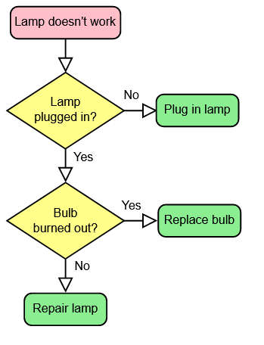
These are the basic symbols used in most flowcharts. However, there are additional symbols and notations that can be used in more complex flowcharts, depending on the specific requirements of the process being depicted. Flowcharts are a versatile tool for visually representing processes and workflows in various fields, including business, engineering, software development, and more.

- What is the purpose of a process flowchart?
To visually represent the decision-making process of a program. Or whatever
- What shapes are typically used to represent different elements in a flowchart?
Rhombus, oval, parallelogram, rectangle, arrow, small circle/dot
- How are the symbols in a flowchart connected to show the sequence of steps in a process?
Ah? I don’t know, man. I just know there’s arrows and funny shapes that mean something different each.
- What are some of the benefits of creating a process flowchart?
It can help understand the logical steps involved in the flow of a program
- Can a process flowchart be created manually?
Yeah.
- What industries or fields commonly use flowcharts?
I don’t know, business guys. Boring people industries.
- How can software tools be leveraged to create a process flowchart?
They can help automate the process of converting a program into a diagram, and vice-versa.
- What does a diamond shape indicate in a flowchart?
A decision.
- What does a parallelogram shape indicate in a flowchart?
Input/Output
- How does standardization make flowcharts more useful?
They can be understood across an industry regardless of traditional language barriers.
- A process flowchart is a diagram that shows the sequential steps of a process and the decisions needed to make the process work.
true
- Process flowcharts use various shapes and symbols to represent different elements and actions within a process.
true
- The diamond shape is used to indicate the beginning or end of a process.
false
- A small circle is used to indicate where multiple lines converge or connect to a single point in the flowchart.
true
- Arrows show the direction of the flowchart and connect the symbols to indicate the sequence of steps in the process.
true
- Flowcharts are graphical representations of services.
false, I guess
- Process flowcharts are standardized such that anyone who has an understanding of flowcharts can look at one and know what is happening.
true
- There are additional symbols and notations that can be used in more complex flowcharts, depending on the specific requirements of the process being depicted.
true
- The parallelogram represents a specific task, action, or operation within the process.
false
- The oval shape represents the beginning or end of a process.
true

